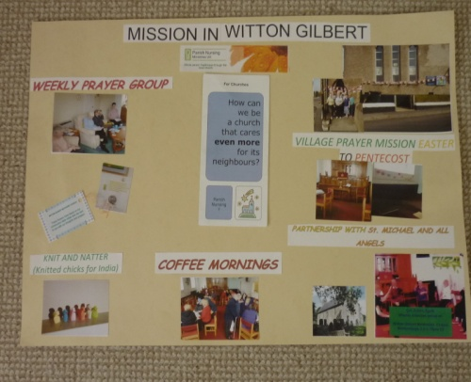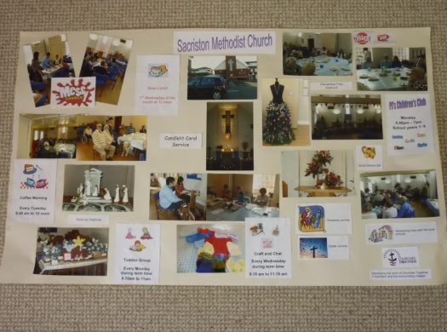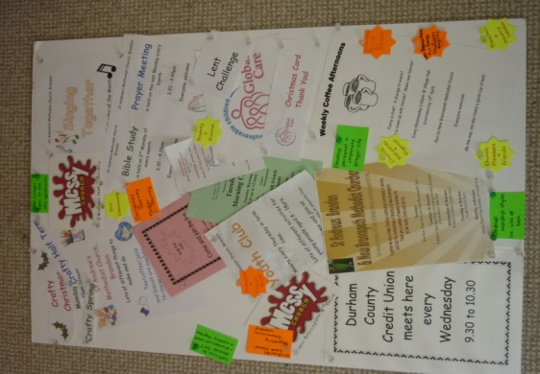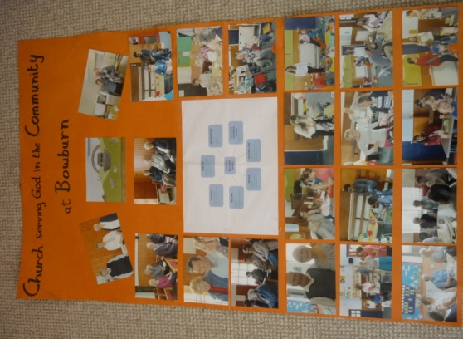

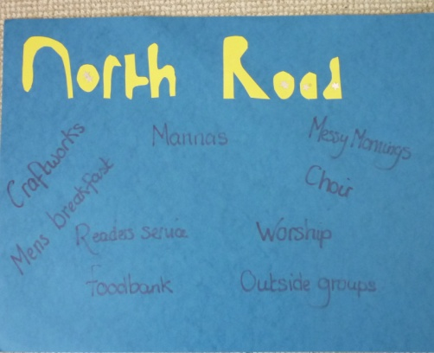
Mission Forum

Virtual Circuit Prayer Walk

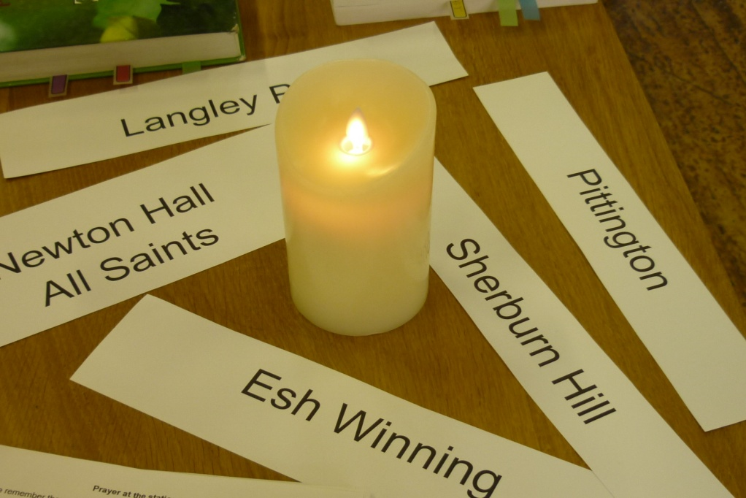

May 21st 2016
Our Churches
Witton Gilbert Sherburn Hill Sacriston Pittington NewBrancepeth Langley Park Esh Winning Bearpark Newton Hall Carrville Brandon Bowburn North Road Framwellgate Moor
Elvet

The Prayer for our Churches
Loving Lord, we remember the people of your church at ......... and the community that they serve.
May the light of your Word shine brightly in this place.
We ask that you lead your people into new ways of meeting the needs of those around them.
May the breath of your Spirit move in this place
Lord, may your people proclaim your whole gospel of hope, inclusion, healing and love
May the bread of life be shared and the water of renewal flow out to all in ........
In the name of our risen Saviour
Amen

Bible References

Leviticus 26: 12-13
Deuteronomy 10: 12
Isaiah 2: 3
Isaiah 30: 21
Isaiah 40: 29 – 31
Jeremiah 6: 16
Micah 6: 8
References used from NRSV translation

Some of our Posters
